Известия Гомельского государственного университета
имени Ф. Скорины, №6(39), 2, 2006

УДК 539.12

Variational perturbation theory and nonperturbative calculations in QCD

I. L. Solovtsov

1. Introduction. The idea of quark-hadron duality was formulated in the paper [1] as follows: inclusive hadronic cross sections, once they are appropriately averaged over an energy interval, must approximately coincide with the corresponding quantities derived from the quark-gluon picture.
The following quantities and functions will be considered here:
- the ratio of hadronic to leptonic -decay widths in the vector channel
(1)
- the “light” Adler function, which is constructed from -decay data
(2)
- the smeared function
(3)
- the hadronic contribution to the anomalous magnetic moment of the muon (in the leading order in electromagnetic coupling constant α)
(4)
where is the vacuum polarization factor;
- the strong interaction contribution to the running of the fine structure constant:
(5)
The approach that we use here to describe the quantities and functions mentioned above is based on the nonperturbative expansion method [2,3,4,5]. We formulate a model that also incorporates a summation of threshold singularities [6] and takes into account the nonperturbative character of the light quark masses [7].
2. The method. The method on which we construct a description of the -related quantities is variational perturbation theory (VPT). Within this approach, a quantity under consideration is represented in the form of the so-called floating or variational series. A certain variational procedure is combined with the possibility of calculating corrections to the principal contribution, which allows the possibility of probing the validity of the leading contribution and the region of applicability of the results obtained. The VPT series is different from the conventional perturbative expansion and can be used to go beyond the weak-coupling regime. This allows one to deal with considerably lower energies than in the case of perturbation theory.
The new expansion parameter is connected with the initial coupling constant by the relation [2, 3]
(6)
where is a positive constant. As follows from (6), for any value of the coupling constant, the expansion parameter obeys the inequality
(7)
While remaining within the range of applicability of the -expansion, one can deal with low-energy processes where is no longer small.
The positive parameter plays the role of an auxiliary parameter of a variational type, which is associated with the use of a floating series. Here we will fix this parameter using some further information, coming from the potential approach to meson spectroscopy. As has been shown in [3], is determined by requiring that tends to 1 for sufficiently large . The behavior of the functions gives evidence for the convergence of the results, in accordance with the phenomenon of induced convergence. The behavior of the -function at large value of the coupling constant, , corresponds to the infrared singularity of the running coupling: at small . In the potential quark model this behavior is associated with the linear growth of the quark-antiquark potential.
The VPT approach allows one to perform the analytic continuation from the Euclidean to Minkowskian region self-consistently [11]. This situation is similar to the analytic approach in QCD [12,13], where the connection space- and timelike regions can also be established self-consistently [14,15]. A problem of transition from the spacelike region, where the running coupling is initially defined by the renormalization group method, to the timelike region within perturbation theory has been discussed in [16,17,18].
Resummation of threshold singularities. In describing a charged particle-antiparticle system near threshold, it is well known from QED that the so-called Coulomb resummation factor plays an important role. This resummation, performed on the basis of the nonrelativistic Schrödinger equation with the Coulomb potential , leads to the Sommerfeld-Sakharov -factor [19,20]. In the threshold region one cannot truncate the perturbative series and the -factor should be taken into account in its entirety. The -factor appears in the parameterization of the imaginary part of the quark current correlator, which can be approximated by the Bethe-Salpeter amplitude of the two charged particles, [21]. The nonrelativistic replacement of this amplitude by the wave function, which obeys the Schrödinger equation with the Coulomb potential, leads to the appearance of the resummation factor in the parameterization of the -function.
For a systematic relativistic analysis of quark-antiquark systems, it is essential from the very beginning to have a relativistic generalization of the -factor. A new form for this relativistic factor in the case of QCD has been proposed in [6]
(8)
where is the rapidity which related to by , in QCD. The function can be expressed in terms of: . The relativistic resummation factor (8) reproduces both the expected nonrelativistic and ultrarelativistic limits and corresponds to a QCD-like Coulomb potential. Here we consider the vector channel for which a threshold resummation -factor for the s-wave states is used. For the axial-vector channel the -factor is required. The corresponding relativistic factor has been found in [27].
To incorporate the quark mass effects one usually uses the approximate expression proposed in [1,22,23] above the quark-antiquark threshold
(9)
where
(10)
The function is taken in the Schwinger approximation [24].
One cannot directly use the perturbative expression for in Eq. (9), which contains unphysical singularities, to calculate, for example, the Adler -function. Instead, one can use the VPT representation for. Besides this replacement, one has to modify the expression (9) in such a way as to take into account summation of an arbitrary number of threshold singularities. Including the threshold resummation factor (8) leads to the following modification of the expression (9) (see [25] and [26]) for a particular quark flavor
(11)
The potential term corresponding to the function gives the principal contribution to , the correction amounting to less than twenty percent for the whole energy interval [27].
Effective quark masses. A solution of the Schwinger-Dyson equations [28,29,30,31] demonstrates a fixed infrared behavior of the invariant charge and the quark mass function. The mass function of the light quarks at small momentum looks like a plateau with a height approximately equal to the constituent mass, then with increasing momentum the mass function rapidly decreases and approaches the small current mass.
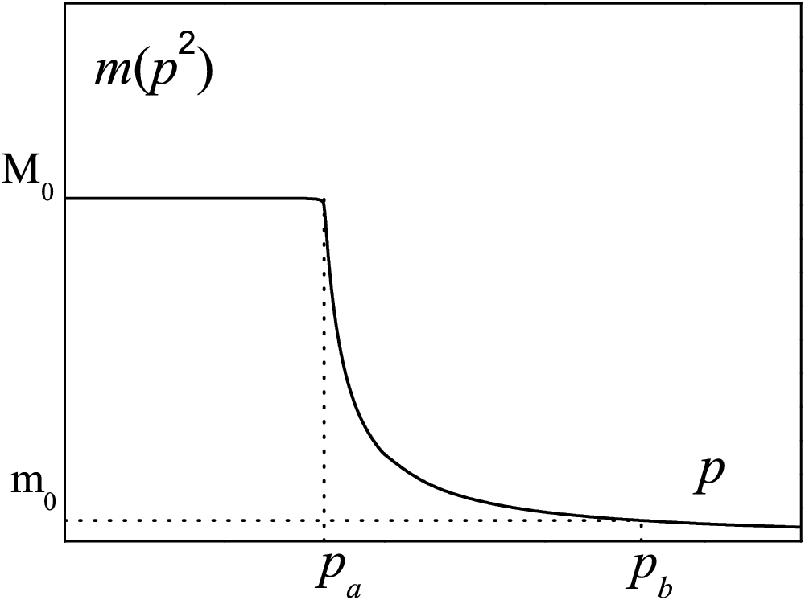
This behavior can be understood by using the concept of the dynamical quark mass. This mass has an essentially nonperturbative nature. Its connection with the quark condensate has been established in [32]. By using an analysis based on the Schwinger-Dyson equations a similar relation has been found in [33]. It has been demonstrated in [34] that on the mass-shall one has a gauge-independent result for the dynamical mass
(12)
Figure 1. Function .
A result obtained in [35] demonstrates the step-like behavior of the mass function. The height of the plateau is given by the quark condensate (12). According to these results it is reasonable to assume that at small the function is rather smooth (nearly constant). In the region – GeV the principal behavior of the function is defined by perturbation theory with the renormalization group improvement.
Table 1. Typical values of and .
(GeV) | 0.004 | 0.007 | 0.130 | 1.35 | 4.4 | 174.0
(GeV) | 0.260 | 0.260 | 0.450 | 1.35 | 4.4 | 174.0

The following analysis was performed by using the model mass function that is shown in Fig. 1. We take the curve that connects the points and to have the form . The parameters are taken from the known values of the running masses at GeV. The values of at GeV [36] and typical values of are shown in Table 1.
3. Physical quantities and functions generated by . In this section we apply the model we have formulated to describe the physical quantities and functions described in the Introduction.
Inclusive decay of the -lepton. The ratio of hadronic to leptonic -decay widths in the vector channel is expressed by Eq. (1), where , is the CKM matrix element, is the electroweak factor, and MeV is the mass of the -lepton [36]. The experimental data obtained by the ALEPH and OPAL collaborations for this ratio are [37,38,39]: , . In our analysis we use the nonstrange vector channel spectral function obtained by the ALEPH collaboration [37] and keep in all further calculations the value as the normalization point. The range of estimates are obtained by varying the quark masses in the interval MeV (this band is fixed rather definitely by the -function considered below) and MeV. The results for are given below.
-function. The experimental information obtained by the ALEPH and OPAL collaborations allows us to construct the nonstrange vector channel “experimental” -function. In order to construct the Euclidean -function we use for the following expression The continuum threshold we find from the global duality relation [40] that gives GeV. The value of agrees with the results of papers [41,42,43]. A similar value of the continuum parameter is used in the QCD sum rules [44,45,46,47].
The low energy -data in the nonstrange vector channel results in the curve for in Figs. 2 and 3. In Fig. 2 we also plot three theoretical curves corresponding to masses of the light quarks of , and MeV. Fig. 2 demonstrates that the shape of the infrared tail of the -function is quite sensitive to the value of the light quark masses. Note the experimental -function turns out to be a smooth function without any trace of resonance structure. The -function obtained in [48] from the data for electron-positron annihilation into hadrons also has a similar property.
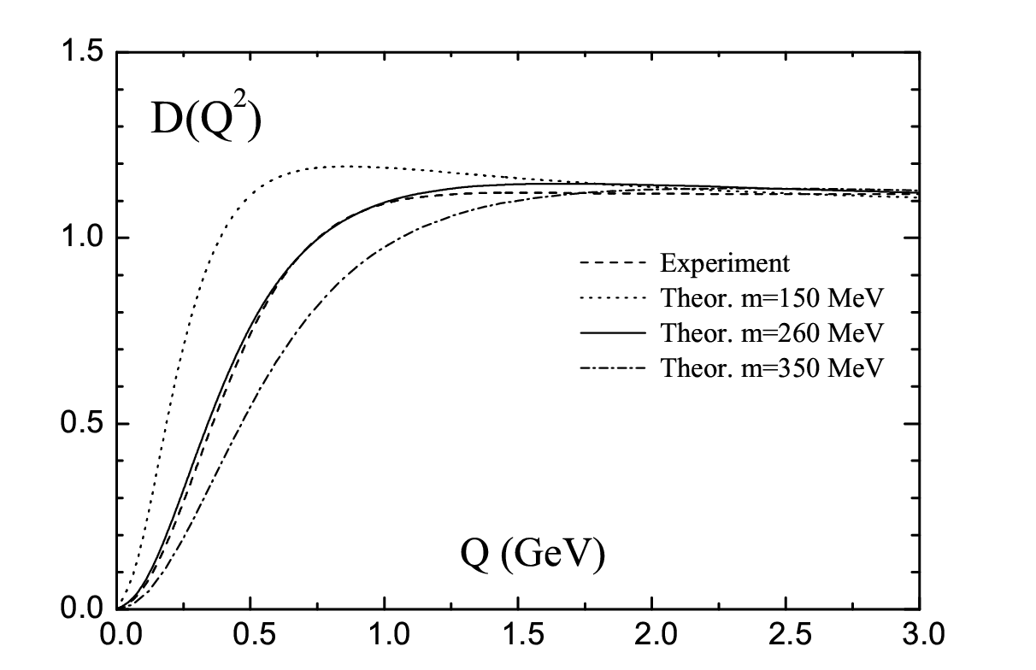 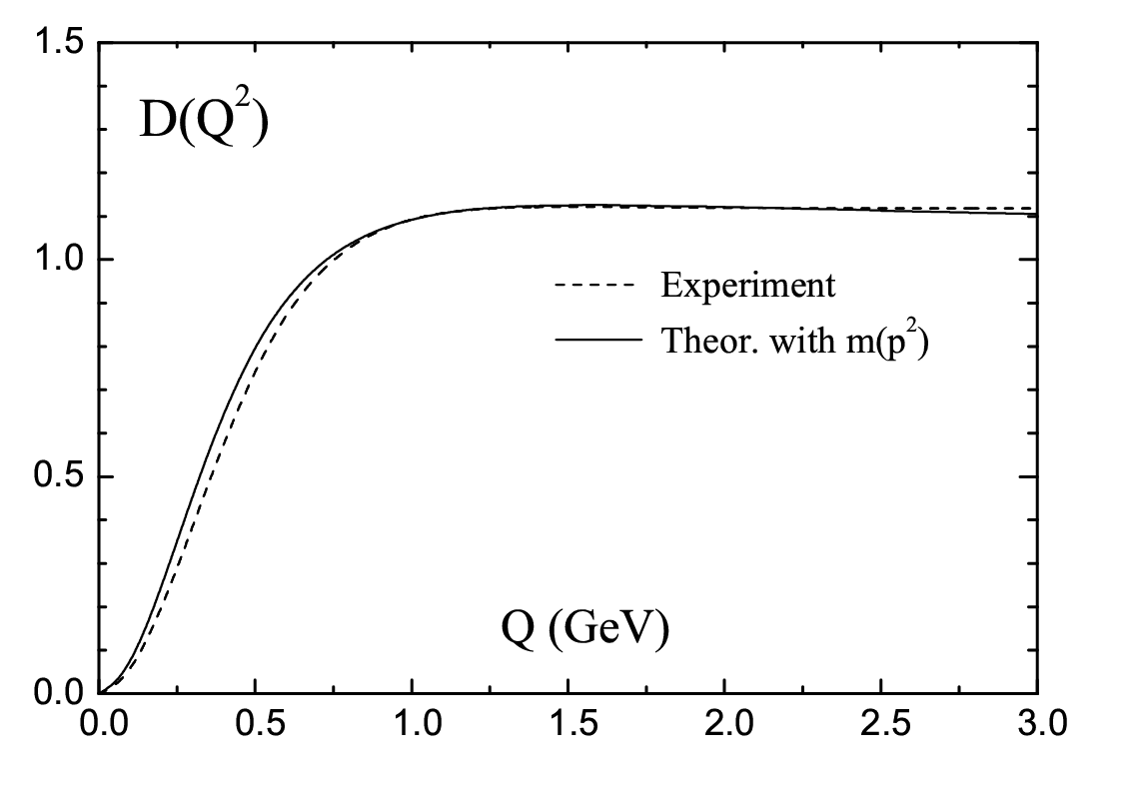 Figure 2. -function for. Figure 3. -function for.
The values of masses MeV agree with the experimental value [37]. The values of the light quark masses are close to the constituent quark masses and therefore incorporate nonperturbative effects. These values are consistent with other results of [49,50] and [51] and with the analysis performed in [41,52] and [53].
-function. Instead of the Drell ratio defined in terms of the discontinuity of the correlation function across the physical cut the smeared function is defined as [1]
(13)
with a finite value of to keep away from the cut. If is sufficiently large and both the experimental data and the theory prediction are smeared, it is possible to compare theory with experiment. Equation (13) and the dispersion relation for the correlator give the representation (3).
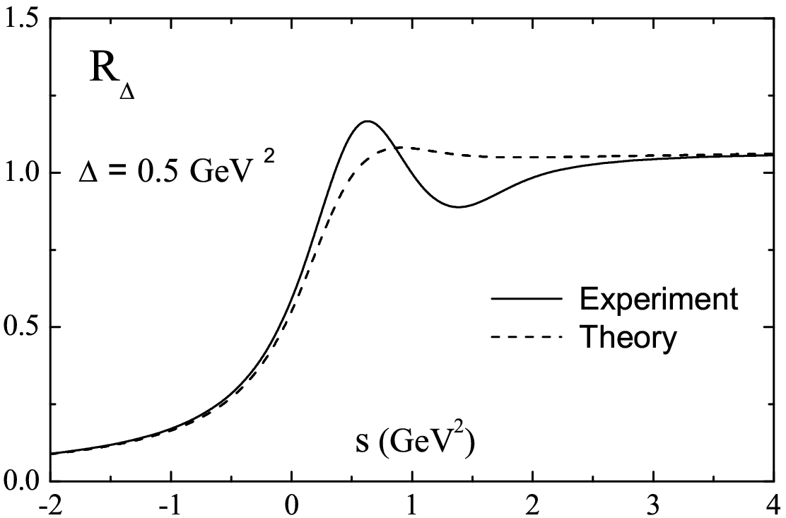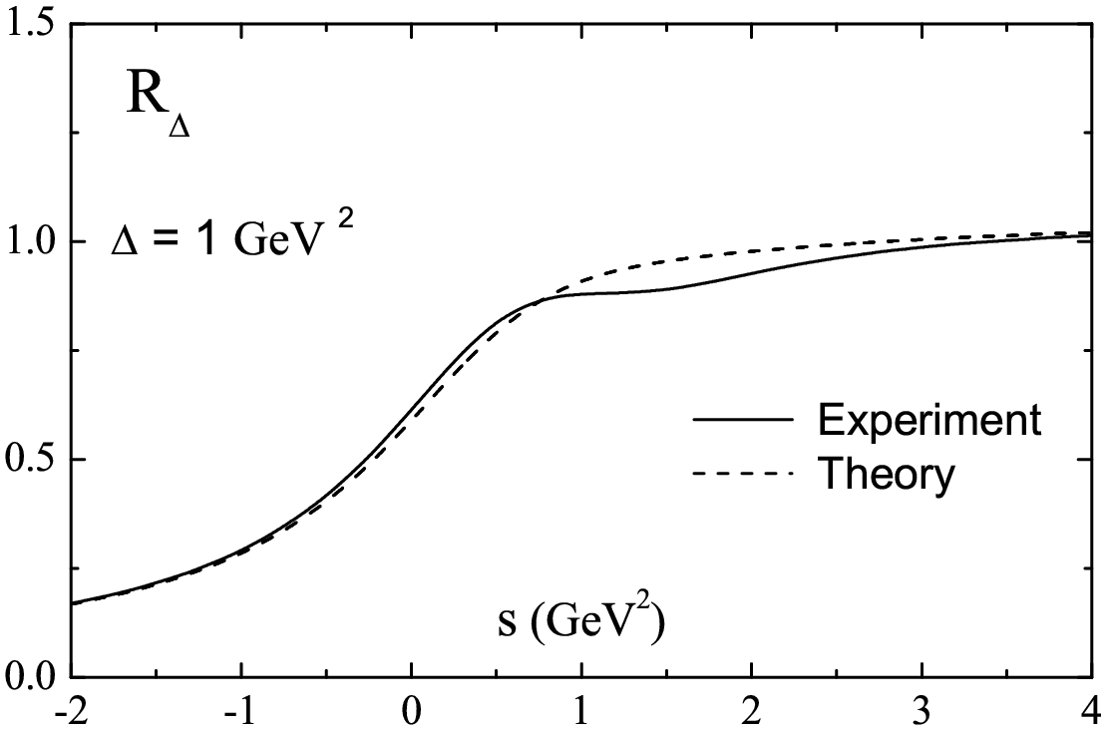
Figure 4. Smeared function for GeV. Figure 5. Smeared function for GeV.

As with the Adler function we will construct the “light” experimental function. For this purpose we match the experimental data taken with to the theoretical result taken with . The value is found from the duality relation.
In Figs. 4 and 5 the experimental and theoretical curves for GeV, GeV and are shown. Let us emphasize that, for reasonable values of , in the spacelike region () there is a good agreement between data and theory starting from .
Hadronic contribution to . The hadronic contribution to the anomalous magnetic moment of the muon in the leading order in the electromagnetic coupling constant is defined by (4), where [36], and K(s) is known function (see, for example, [24]). The muon mass is MeV.
The expression (4) can be rewritten in terms of the -function
(14)
It is should be emphasized that the expressions (4) and (14) are equivalent due to the analytic properties of the function. If one uses a method that does not maintain the required properties of , expressions (4) and (14) will no longer be equivalent and will imply different results [54]. This situation is similar to that which occurs in the analysis of inclusive -decay [55]. Within VPT one is justified in doing this, and can use equally well either the expression (4) or the expression (14).
In our calculations we take into account the matching conditions at quark thresholds according to the procedure described in [15]. If we take for the parameter in the function the best fit value MeV and vary – MeV, we get
The method based on the analytic perturbation theory leads to the close result: [7]. Alternative “theoretical” values of are extracted from annihilation and decay data: (-based) [56] which is 1.9 below the BNL experiment; [57] (-based) [56] which is within 0.7 of experiment; and (-based) [58] 2.7 below experiment. An even lower value is given in [59].
Hadronic contribution to the fine structure constant. Consider the hadronic correction to the electromagnetic fine structure constant at the -boson scale. The evolution of the running electromagnetic coupling is described by
The leptonic part is known up to the three-loop level, [60]. It is conventional to separate the contribution coming from the first five quark flavors. The contribution of the -quark is estimated as [61].
At the -boson scale we get
This value is to be compared with predictions extracted from a wide range of data describing hadrons [59]:
The result based on the analytic perturbation theory is [7]. We see that our result is consistent with previous theoretical/experimental evaluations, with comparable uncertainties.
4. Summary. A method of performing QCD calculations in the nonperturbative domain has been developed. This method is based on the variational perturbation theory in QCD, takes into account the summation of threshold singularities and the involvement of nonperturbative light quark masses.
The following quantities have been analyzed: the inclusive -decay characteristic in the vector channel, ; the light-quark Adler function, ; the smeared -function; the hadronic contribution to the anomalous magnetic moment of the muon, ; and the hadronic contribution to the fine structure constant, . We have demonstrated that the proposed method allows us to describe these quantities rather well.

Acknowledgments. It is a pleasure to thank K.A. Milton, D.V. Shirkov, A.N. Sissakian and O.P. Solovtsova for interest in the work and useful discussion. I also gratitude to A.N. Serdukov and N.V. Maksimenko for the kind invitation to participate at the conference. This work was supported in part by the International Program of Cooperation between the Republic of Belarus and JINR and the BRFBR (contract #F06D-002).

Abstract. A method based on variational perturbation theory in quantum chromodynamics is applied to describe hadronic contributions to different physical quantities.

References

1. E. C. Poggio, H. R. Quinn and S. Weinberg, Phys. Rev. D13, 1958 (1976).
2. I. L. Solovtsov, Phys. Lett. B327, 335 (1994).
3. I. L. Solovtsov, Phys. Lett. B340, 245 (1994).
4. A. N. Sissakian and I. L. Solovtsov, Phys. Part. Nucl. 25, 478 (1994).
5. A. N. Sissakian and I. L. Solovtsov, Phys. Part. Nucl. 30, 461 (1999).
6. K. A. Milton and I. L. Solovtsov, Mod. Phys. Lett. A16, 2213 (2001).
7. K. A. Milton, I. L. Solovtsov and O. P. Solovtsova, Mod. Phys. Lett. A21, 1355 (2006).
8. W. E. Caswell, Ann. Phys. 123, 153 (1979).
9. J. Killingbeck, J. Phys. A14, 1005 (1981).
10. P. M. Stevenson, Nucl. Phys. B231, 65 (1984).
11. H. F. Jones and I.L. Solovtsov, Phys. Lett. B349, 519 (1995).
12. D. V. Shirkov and I. L. Solovtsov, JINR Rapid Comm. No.276.-96, 5, hep-ph/9604363.
13. D. V. Shirkov and I. L. Solovtsov, Phys. Rev. Lett. 79, 1209 (1997).
14. K. A. Milton and I. L. Solovtsov, Phys. Rev. D55, 5295 (1997).
15. K. A. Milton and O. P. Solovtsova, Phys. Rev. D57, 5402 (1998).
16. A. V. Radyushkin, Optimized Λ-parametrization for the QCD running coupling constant in spacelike and timelike region, Preprint E2-82-159, JINR (1982), hep-ph/9907228.
17. N. V. Krasnikov and A. A. Pivovarov, Phys. Lett. B116, 168 (1982).
18. J. D. Bjorken, Two Topics in Quantum Chromodynamics, Preprint PUB-5103, SLAC (1989).
19. A. Sommerfeld, Atombau und Spektrallinien, Vol. 2 (Vieweg, Braunschweig, 1939).
20. A. D. Sakharov, Sov. Phys. JETP, 18, 631 (1948).
21. R. Barbieri, P. Christillin and E. Remiddi, Phys. Rev. D8, 2266 (1973).
22. T. Appelquist and H. D. Politzer, Phys. Rev. Lett. 34, 43 (1975).
23. T. Appelquist and H. D. Politzer, Phys. Rev. D12, 1404 (1975).
24. J. Schwinger, Particles, Sources and Fields, Vol. 2 (New York, Addison-Wesley, 1973).
25. K. A. Milton, I. L. Solovtsov and O. P. Solovtsova, Phys. Rev. D64, 016005 (2001).
26. A. N. Sissakian, I. L. Solovtsov and O. P. Solovtsova, JETP Lett. 73, 166 (2001).
27. I. L Solovtsov, O. P. Solovtsova and Yu. D. Chernichenko, Phys. Part. Nucl. Lett. , No. 4, 199 (2005).
28. C. D. Roberts and S. M. Schmidt, Prog. Part. Nucl. Phys. 45, S1 (2000).
29. C. S. Fisher and R. Alkofer, Phys. Lett. B536, 177 (2002).
30. C. S. Fisher and R. Alkofer, Phys. Rev. D67, 094020 (2003).
31. A. C. Aguilar, A. V. Nesterenko and J. Papavassiliou, hep-ph/0510117.
32. H. D. Politzer, Nucl. Phys. B117, 397 (1976).
33. N. V. Krasnikov and A. A. Pivovarov, Sov. Phys. J. 25, 55 (1982).
34. V. Elias and M. D. Scadron, Phys. Rev. D30, 647 (1984).
35. L. J. Reinders and K. Stam, Phys. Lett. B195, 465 (1987).
36. Particle Data Group, S. Eidelman et al., Phys. Lett. B592, 1 (2004).
37. ALEPH Collab., R. Barate et al., Eur. Phys. J. C4, 409 (1998).
38. M. Davier and Ch. Yuan, Nucl. Phys. B (Proc. Suppl.) 123, 47 (2003).
39. OPAL Collab., K. Ackerstaff et al., Eur. Phys. J. C7, 571 (1999).
40. S. Peris, M. Perrottet and E. de Rafael, JHEP, 9805, 011 (1998).
41. A. E. Dorokhov, Phys. Rev. D70, 094011 (2004).
42. E. de Rafael, Phys. Lett. B322, 239 (1994).
43. S. Narison, Nucl. Phys. B (Proc. Suppl.) 96, 364 (2001).
44. M. A. Shifman, A. I. Vainshtein and V. I. Zakharov, Nucl. Phys. B147, 385 (1979).
45. M. A. Shifman, A. I. Vainshtein and V. I. Zakharov, Nucl. Phys. B147, 448 (1979).
46. M. A. Shifman, A. I. Vainshtein and V. I. Zakharov, Nucl. Phys. B147, 519 (1979).
47. L. J. Reinders, H. R. Rubinstein and S. Yazaki, Phys. Rep. 127, 1 (1985).
48. S. Eidelman, F. Jegerlehner, A. L. Kataev, O. Veretin, Phys. Lett. B454, 369 (1999).
49. A. I. Sanda, Phys. Rev. Lett. 42, 1658 (1979).
50. J. J. Sakurai, K. Scilcher and M. D. Tran, Phys. Lett. B102, 55 (1981).
51. D. V. Shirkov and I. L. Solovtsov, in: Proc. Int. Workshop on Collisions from to , eds. G. V. Fedotovich and S. I. Redin (Budker Inst. Phys., Novosibirsk, 2000) pp. 122-124.
52. A. E. Dorokhov, Acta Phys. Polon. B36, 3751 (2005).
53. A. E. Dorokhov and W. Broniowski, Eur. Phys. J. C32, 79 (2003).
54. K. A. Milton and O. P. Solovtsova, Int. J. Mod. Phys. A17, 3789 (2002).
55. K. A. Milton, I. L. Solovtsov and O. P. Solovtsova, Phys. Lett. B415, 104 (1997).
56. M. Davier, S. Eidelman, A. Hocker and Z. Zhang, Eur. Phys. J. C31, 503 (2003).
57. Muon Collab., G.W. Bennett et al., Phys. Rev. Lett. 92, 161802 (2004).
58. A. Hocker, in: Proc. the XXXII Int. Conf. ICHEP’04, eds. H. Chen et al. (World Scientific, 2005), Vol. 2., p. 710, hep-ph/0410081.
59. K. Hagiwara, A. D. Martin, D. Nomura, and T. Teubner, Phys. Rev. D69, 093003 (2004).
60. M. Steinhauser, Phys. Lett. B429, 158 (1998).
61. J. H. Kuhn and M. Steinhauser, Phys. Lett. B437, 425 (1998).

P. Sukhoi Technical University, Поступило 11.09.06
Gomel, Belarus

It has been observed empirically [8, 9] that the results seem to converge if the variational parameter is chosen, in each order, according to some variational principle. This induced-convergence phenomenon is also discussed in [10].

